Random breath test ‘numbers game’ strategy slammed by WA Police

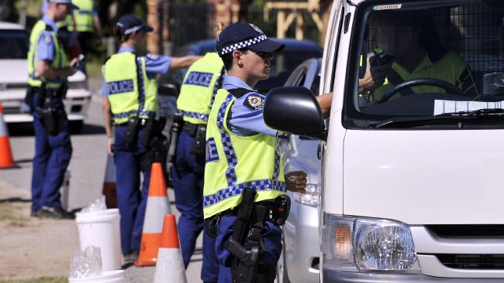

The controversial “Booze Buses’’ first came to WA in 1988 amid howls of protest from civil right activists, as being a restriction on Individuals freedom. The ‘’Booze Buses “Has now been slammed by WA front line police officers.

More than 90 per cent of the officers surveyed said in relation to booze buses that they feel WA Police are more concerned about “the number of drivers tested ... instead of drivers tested that return a positive sample”.
“Many Police officers expressed that they would like to spend more hours on the road performing traffic duties but they are unable to do so because they are either: bogged down with administrative issues; do not have sufficient time in their work day; are unable because of a lack of staff, or are unable because of a lack of resources,” the union said.

The Police survey’s key findings
MORE than 90 per cent felt in relation to booze buses, WA Police are more concerned about “the number of drivers tested ... instead of drivers tested that return a positive sample”
56 PER CENT do not believe major alcohol and drug testing is conducted “in the right place, at the right time”.
72 PER CENT believe targeted alcohol and drug testing is more effective than random testing.
MORE than 70 per cent did not believe local police knowledge was taken into consideration.
81 PER CENT said police presence on the road was the single most effective tool to modify road user behavior.
65 PER CENT of officers said their station or section was not properly resourced to conduct traffic duties.
62 PER CENT believed they should be spending more hours on the road.

- Do you agree with the “Booze Buses”? Explain your answer
- What do you think are their advantages and disadvantages? Explain.
- What are the concerns of the WA Police officers surveyed? Explain

